# **Assignment 1**

1. Acme Builder’s Inc. has worked out that the wiring of an average house requires 45m of 14AWG wire. If a contractor has to wire 5 houses, what length of wire will be needed?

~~Ans: Acme Builder’s Inc. has worked out that the wiring of an~~ average house requires 45m of 14AWG wire. If a contractor has to wire 5 houses, what length of wire will be needed?

|  |  |  |
| --- | --- | --- |
| Input | Processing | Output |
| Number of House | House equivalents to the given wire | Length of wire |
|  | Calculate number of Houses multiplied to length of wire per one house |  |

Sample Calculations:

* Input Number of house to wire which is (5), multiplied by 45 meters (On an average house)
* Answer would be 225 meters for the total length of wire needed.
* **Problem is solvable.**

My Assumptions are as follows:

* If given from the 5 houses, there will be 1 or 2 probability that the house from the 5 houses given would be a large one like mansion for example. That would require more than the average length of wire needed. Depends on the type of the house I would suggest the meters will also depends on that type of a house (small, average, large) to support the needed material.

1. Burnaby Farms wants to estimate the cost of fertilizing their fields for the coming year. Each hectare of cultivated land requires 15kg and they intend to work 300 hectares.

Ans: ~~Burnaby Farms wants to estimate the cost of fertilizing their fields for the coming year~~. Each hectare of cultivated land requires 15kg and they intend to work 300 hectares.

|  |  |  |
| --- | --- | --- |
| Input | Processing | Output |
| Number of Intended work (in hectares) | Calculate Number of hectares and the volume of fertilizer | Cost of fertilizer |

Sample Calculations:

* = 300 x 15 kg = 4500 kg. – 4500 kg of fertilizer needed.
* The **Problem is not solvable** since it is asking for the cost of fertilizer, and no price value indicated.

***My Assumptions:***

|  |  |  |
| --- | --- | --- |
| Input | Processing | Output |
| Number of Intended work (in hectares) | Calculate Number of work in hectares multiplied by the volume of fertilizer | Cost of fertilizer |
| Price of fertilizer | Calculate total volume of fertilizer by the price of the fertilizer |  |

If given fertilizer price is $26/2kg.

Additional Calculations: 4500kg x $26 / 2kg = $58,500

The **problem will be solvable** if given the fertilizer price and when total volume is calculated.

1. Cherry Entertainment Corp. is looking into the profitability of hosting MMA XXII at the Rogers Center. The sale of tickets, broadcasting rights and advertising will gross approximately $2 million. How much profit will Cherry Entertainment Center make if Rogers Centre cost $800, 000?

Ans: ~~Cherry Entertainment Corp. is looking into the profitability of hosting MMA XXII at the Rogers Center.~~ The sale of tickets, broadcasting rights and advertising will gross approximately $2 million. How much profit will Cherry Entertainment Center make if Rogers Centre cost $800, 000?

|  |  |  |
| --- | --- | --- |
| Input | Processing | Output |
| Sales value | Calculate by subtracting gross value and rental expense | Profit |

Sample Calculations:

* + If given actual value is $2.123 million.
  + $2,123,000 - $800,000 = $1,323,000
  + Total profit will be = $1,323,000
  + **Problem is solvable**

***My Assumption:***

is to work on other expenses to include aside from the rental alone and to classify gross value of sales into parts.

|  |  |  |
| --- | --- | --- |
| Input | Processing | Output |
| Ticket Sales | Calculate ticket sales, broadcasting rights and advertising by addition. | Total Profit |
| Broadcasting rights | Calculate by subtracting Sales value and rental expense |  |
| Advertising |  |

4. Delta Airlines estimates that the fuel efficiency of a Boeing 747 jet is 12 liters per km. If the price of aviation fuel is $1 per liter, how much would it cost the airline to fly to New York and back from Toronto?

Ans: ~~Delta Airlines estimates that the fuel efficiency of a Boeing 747 jet~~ is 12 liters per km. If the price of aviation fuel is $1 per liter, how much would it cost the airline to fly to New York and back from Toronto?

|  |  |  |
| --- | --- | --- |
| Input | Processing | Output |
| *Missing input for # of km to take from point A to point B | Calculate price and distance by km | Cost to fly from point A – point B |
| Calculate by Multiplying to two (flight is vice-versa) |

**Problem is not solvable** since we need a distance value to calculate how many km will it take multiplied by the number of liters that would cost.

**Problem is solvable** Assuming the distance will take 570 km from given 2 places, my calculations would be:

* ((570km * $1) * (12 liters / $1)) (2)
* 570~~km~~/$1 * ~~1km /~~ 12liters (2)
* $6840 * 2 (vice versa)
* $13,680 total cost to fly from point A to point B per liter

1. Estelle’s Grocery is having a back-to-school sale of up to 50% off on most food items. The price of potatoes is 11₵ per kg. A plastic bag costs 5₵. What will the total cost (potatoes and bag) if someone buys 25kg of potatoes?

Ans: ~~Estelle’s Grocery is having a back-to-school sale of up to 50% off on most food items.~~ The price of potatoes is 11₵ per kg. A plastic bag costs 5₵. What will the total cost (potatoes and bag) if someone buys 25kg of potatoes?

|  |  |  |
| --- | --- | --- |
| Input | Processing | Output |
| Item bought | Calculate Item bought and price of potato | Total Cost of potato |
|  | Assign total Cost to calculated total. |  |
|  | Calculate total cost by subtracting the discount from food items |  |

Sample Calculations:

* 11c / 1kg and if item bought = 25kg of potatoes
* Item bought * (11c / 1kg) + (# of plastic bags * 5c)
* 25 ~~kg~~ * (11c / ~~1kg~~) + (# of bag * 5c)
* 275c cost of potatoes – (totalCost * .50) + (# of bag * 5c)
* total cost would be 137.5c with 50% discount (food item)

|  |  |  |
| --- | --- | --- |
| Input | Processing | Output |
| No. of bags required | Calculate No. of bags to price of bags per piece. | Total Cost of Potato with bags |
|  | Calculate total cost and price of bags |  |

**Problem is solvable** but would require the user’s input for number of bags need to be. Assuming if 1 bag is equivalent to 5kg of potatoes. 25kg of potato would require 5 bags.

My assumption would be:

* Total cost of food item + 5 bags (if 5kg will fit to 1 bag)
* 137.5c + 5(5c)
* 137.5c + 25c
* 162.5c Total cost with bag

1. Fancy Jewelers is located in the Scarborough Town Center on the second floor near to Wal-Mart. In their Boxing week sale earrings were priced at $20 per pair. If Narendra wants to get a pair for as many females in his family as he can. How many pairs can he get if he has $125? [You may assume that there are more females in his family than he can buy earrings.

Ans: ~~Fancy Jewelers is located in the Scarborough Town Center on the second floor near to Wal-Mart. In their Boxing week~~ sale earrings were priced at $20 per pair~~. If Narendra wants to get a pair for as many females in his family as he can.~~ How many pairs can he get if he has $125? [You may assume that there are more females in his family than he can buy earrings.]

|  |  |  |
| --- | --- | --- |
| Input | Processing | Output |
| Money on hand | Calculate Money on hand by dividing it to Sale price item. | No. of pair of earrings he can buy |
| No. of female/s in the family | Calculate No. of members that can have and cannot have by returning the remainder using modulus (%). | No. of female in the family that can’t have a pair of earrings |

Sample Calculation:

* Given if no. of females in his family is 7
* Money on hand / Sale price
* $125 / $20
* 6 pairs of earrings he can buy
* 7 (No. of female in the family) / 6 (Pair of earrings)
* = 1 female family member that can’t have a pair of earrings.

**Problem is solvable.**

1. Gerard The Plumber charges $1.25 per meter for pipe installation. Each join cost 90₵. How much will Gerard charge for a job that is 12m with 4 joins?

~~Gerard The Plumber charges~~ $1.25 per meter for pipe installation. Each join cost 90₵. How much will Gerard charge for a job that is 12m with 4 joins?

|  |  |  |
| --- | --- | --- |
| Input | Processing | Output |
| Length in meters | Calculate Plumber charge multiplied by length | Installation charge |
| Number of Joins | Calculate cost of joins to number of joins and convert amount from cents to dollar |  |
|  | Calculate installation charge by addition of plumber charge and join cost. |  |

Sample Calculation:

Plumber charge = $1.25 / 1 meter

Join cost – 90 cents

$1.25 / 1~~m~~ x 12~~m~~ = $15 plumber charge

90 ~~cents~~ / 1 joins x 4 ~~joins~~ 360 cents

360 ~~cents~~ x $1 / 100 ~~cents~~ = $3.6

$15 plumber charge + $3.6 join cost

= $18.6 total charge

**Problem is solvable.**

1. Last year at the CNE, the Halls family bought 50 ride tickets. If the Polar Express, the Ferris Wheel, the HighDrop and the WaterFall requires 15, 10, 12 and 9 tickets respectively, how many tickets will remain at the end of the day?

Ans: ~~Last year at the CNE, the Halls family~~ bought 50 ride tickets. If the Polar Express, the Ferris Wheel, the HighDrop and the WaterFall requires 15, 10, 12 and 9 tickets respectively, how many tickets will remain at the end of the day?

**Problem is not solvable because of insufficient data given.**

My assumption would be:

The Halls family should have given total tickets for the day that is on hand. If given is 50 ride tickets same as last year or might be more or less. My computation as follows.

|  |  |  |
| --- | --- | --- |
| Input | Processing | Output |
| *Bought Tickets | Calculate by adding all Ride Tickets used. | Tickets consumed |
| Ride Tickets 1 | Tickets Remaining |
| Ride Tickets 2 | Calculate by getting the modulus of total tickets on hand and tickets bought. |  |
| Ride Tickets 3 |  |
| Ride Tickets 4 |  |

Sample Calculation:

= 15 + 10 + 12 + 9 = 46

= Bought Tickets Assuming is 52, 46 % 52 = 6

= 46 tickets consumed and 6 tickets remains

assuming 52 tickets bought for that day.

**Problem is Solvable** with additional data given from the problem.

1. Isabelle’s Confectionary sells a packet of Maynard’s sourdrops for 25₵. Each packet contains approximately 30 candies. How many packets will Sarah get if she has $3?

Ans: Isabelle’s Confectionary sells a packet of Maynard’s sourdrops for 25₵. ~~Each packet contains approximately 30 candies~~. How many packets will Sarah get if she has $3?

|  |  |  |
| --- | --- | --- |
| Input | Processing | Output |
| Sarah’s Money | Conversion of dollar to cents | Total Packets of Maynard’s sourdrops |
|  | Calculate in cents by dividing Sarah’s money and price of packets |  |

Sample Calculation:

$1 = 100cents

~~$~~ 3 divide by ~~$1~~/100cents = 300 cents

Total packets = 300cents / 25cents

Total Packets = 12 packets

therefore, **Problem is solvable**

1. Jake’s Towing Services works out of the Markham/Finch area. They charge $5.50 per km for towing in addition to a flat service fee of $18. What would be the cost of towing a Toyota RAV 4 from Morningside/Ellesmere to McCowan/Sheppard?

~~Jake’s Towing Services works out of the Markham/Finch area.~~ They charge $5.50 per km for towing in addition to a flat service fee of $18. What would be the cost of towing a Toyota RAV 4 from Morningside/Ellesmere to McCowan/Sheppard?

Following solution is my assumption with reference to google map in getting the distance in km to take.

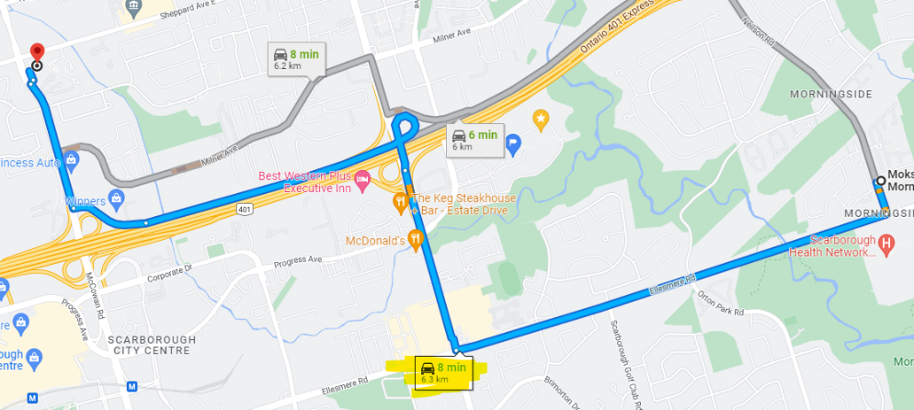

From Morningside/Ellesmere to McCowan/Sheppard, it would take 6.3km according to google map by driving a car.

|  |  |  |
| --- | --- | --- |
| Input | Processing | Output |
| Distance travelled in kilometer | Calculate Distance Charge Amount by multiplying Distance travelled and Towing Charge | Towing Charge |
|  | Calculate by Addition the flat service fee of Distance charge amount |  |

Assuming distance travelled would take 6.3km

Sample Calculation:

= ($ 5.50/~~km~~)(6.3 ~~km~~), = $ 34.65

= $ 34.65 + $18

= $ 52.65 Towing charge for Toyota RAV 4.

**Problem is solvable**, assuming the distance travelled - we get the total towing charge.